**Interpolation:**

The process of estimating the value of y, for any intermediate value of x, is called interpolation.

**Extrapolation:**

The method of computing the value of y, for a given value of x, lying outside the table of values of x is known as extrapolation.

**Muller’s Method:**

In Muller’s method, f (x) = 0 is approximated by a second degree polynomial; that is by a quadratic equation that fits through three points in the vicinity of a root. The roots of this quadratic equation are then approximated to the roots of the equation f (x) 0.This method is iterative in nature and does not require the evaluation of derivatives as in Newton.

Raphson method. This method can also be used to determine both real and complex roots

of f(x) = 0.

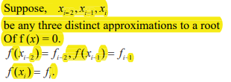

**Newton -Raphson Method**

This method is one of the most powerful method and well known methods, used for finding a root of f(x)=0 the formula many be derived in many ways the simplest way to derive this formula is by using the first two terms in Taylor’s series expansion of the form,

